Date | Topic
w/c 28th July | Image-sharing First Post  (suitable for Facebook, Instagram and LinkedIn):  For a child or young person, having a nude image or video of themselves shared online can be a distressing situation. Report Remove by Childline & the IWF lets young people report nude images/videos shared online for removal. If a child or young person is under 18, they can use the Report Remove tool by following these three steps:  1️Confirm their age.  2️ Log in/create a Childline account for updates.  3️ Share the image securely with the IWF for review and removal.  Childline will let the young person know the outcome of their report and provide further support where needed. For more information 👉 https://t.ly/rRzAu  (suitable for X/Twitter):  Report Remove by Childline & the IWF lets young people report nude images/videos shared online for removal.  If a child or a young person you know is worried about this, talk to them about Report Remove.  More information about Report Remove: https://t.ly/rRzAu  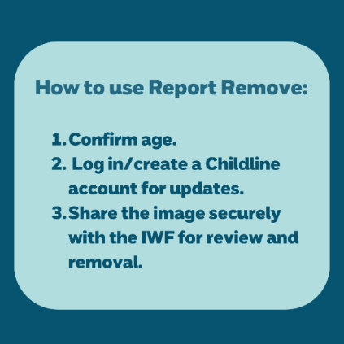
w/c 28th July | Image sharing post Second Post  Links to Image sharing media piece.  Young people from Leeds Youth Council have teamed up with the NSPCC to talk openly and honestly about the risks of sharing images online. Their voices are powerful, their message is clear: you have the right to be safe and in control of your digital life.  🎥 Watch the video here: [Insert YouTube Link]  🔗 Learn more about staying safe online: https://www.nspcc.org.uk/keeping-children-safe/online-safety/
w/c 4th August | Where to get support  (suitable for Facebook, Instagram and LinkedIn):  It’s important that children know where to get support if they ever need it. We encourage talking to your child about what they’re doing online, so they know they can always come to you. We also know that sometimes, no matter how hard we try, there may be things that children find it hard to open up about, so it’s important that we give them other options. That could be speaking to someone else they feel safe and comfortable with:  🔹 another adult they trust e.g. aunt, older cousin etc.  🔹 a teacher or member of the pastoral team in school.  🔹 Childline on 0800 1111 or visiting the Childline website at childline.org.uk.  (suitable for X/Twitter):  Its important children know where to get support. Talk to your child about their online activities so they know they can come to you. If they find it hard to open up, provide other options:  🔹 Another adult they trust.  🔹 Teachers or school staff.  🔹 Childline: 0800 1111 or visit childline.org.uk.  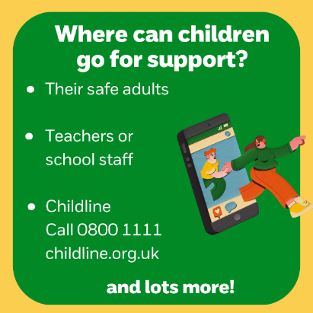
w/c 11th August | Gaming & Social Media First Post  - Links to Gaming Leeds Media piece.  (suitable for Facebook, Instagram and LinkedIn):  Online games can be a great way for children and young people to keep busy and stay in touch with friends and family, but it’s important that they play safely. What should you consider if your child games online?  🔹 Age ratings of games  🔹 Messaging and contact features  🔹 In-game purchases  🔹 Trolling, bullying, and scams  🔹 Reporting issues  🔹 Sources of further support  For more advice about online gaming, visit the NSPCC’s Online Safety Hub: rb.gy/r7j2xq  (suitable for X/Twitter):  Online games can be fun and social, but safety is key. Consider:  🔹 Age ratings of games  🔹 Messaging and contact features  🔹 In-game purchases  🔹 Trolling, bullying, and scams  🔹 Reporting issues  🔹 Sources of further support  For more tips visit: rb.gy/r7j2xq  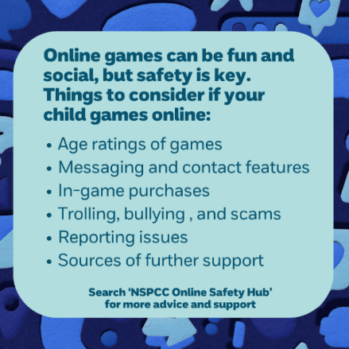  Gaming & Social Media Second Post  👨‍👩‍👧‍👦 Wise Words from Young Voices 👧👦  Pupils from St Francis Catholic Primary School in Morley have a message for parents: you play a vital role in helping us stay safe online and in the real world.  In this heartfelt video, the children, as digital leaders, share their own advice for grown-ups — from listening more, to talking openly about safety and feelings. Their insights are a powerful reminder that safeguarding is a team effort.  🎥 Watch the video here: [Insert YouTube Link]  💡 Learn more about how to support your child’s safety: https://www.nspcc.org.uk/keeping-children-safe/
w/c 18th August | Tips for speaking to your child  (suitable for Facebook, Instagram and LinkedIn):  There’s lots of benefits to children being online, but it’s normal to be worried about your child going online. If you have concerns about what your child is seeing, sharing or who they're speaking to online, here are [our/the NSPCC’s] top tips for how to speak to them about it:  👉 Try to remain calm and balanced – be curious, not furious.  👉 Be positive, but honest about anything you’re worried about.  👉 Ask if they’re worried about anything and let them know they can come to you or another safe adult.  For more information visit the NSPCC Online Safety Hub here: bit.ly/3KnIl27 #NSPCCParenting  (suitable for X/Twitter):  Worried about your child's online activity? Here are [our/the NSPCC's] top tips:  👉 Stay calm – be curious, not furious.  👉 Be positive but honest about concerns.  👉 Ask if they’re worried and let them know they can come to you.  For more info: https://rb.gy/bawjvw  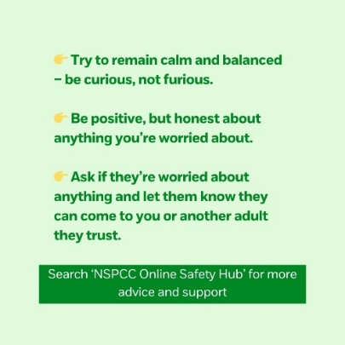  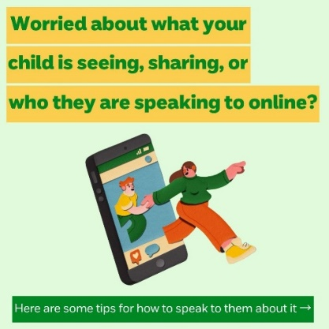
w/c 25th August | Online bullying  - Links to online bullying media piece.  (suitable for Facebook, Instagram and LinkedIn):  Bullying and online bullying often come hand in hand; it’s important to remember that a child’s online world is a part of their everyday world and there can be lots of crossover. Here are some signs and impact of online bullying:  🔹 Sudden and unexplained changes in behaviour and mood  🔹 Withdrawal from online and offline activities  🔹 Fear of taking part in online or offline activities  🔹 Low self-esteem and highly self-critical  🔹 Problems with sleeping or eating  🔹 Impact on wellbeing  For more information on online bullying and how to support young people, go to: https://rb.gy/itots2  (suitable for X/Twitter):  Worried a child is being bullied online? Watch for these signs:  🔹 Sudden mood changes  🔹 Withdrawing from activities  🔹 Fear of participation  🔹 Low self-esteem, self-criticism  🔹 Sleep/eating issues  🔹 Decline in mental health  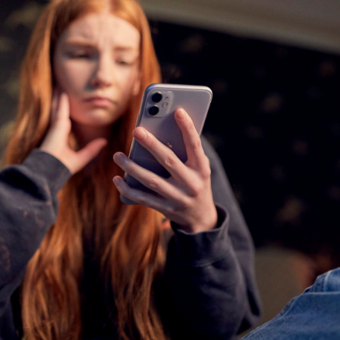  The NSPCC is here to support you: rb.gy/itots2
w/c 1st September | Online wellbeing Post One  (suitable for Facebook, Instagram and LinkedIn):  Talking to your child about their online activities may feel tricky at first. But regular conversations can help build your child’s confidence and may bring you closer together. Here’s [our/the NSPCC’s] top tips for having those conversations:  🔹 Consider your approach  🔹 Ask open questions  🔹 Let them guide you  🔹 See things from their point of view  For more advice on how to support your family’s online wellbeing, search NSPCC Positively Online: rb.gy/1r07iq  (suitable for X/Twitter):  Talking about online activities can be tricky, but regular chats build confidence and closeness. Here are NSPCC's top tips:  🔹 Consider your approach  🔹 Ask open questions  🔹 Let them guide you  🔹 See things from their perspective  For more advice 👉 rb.gy/1r07iq  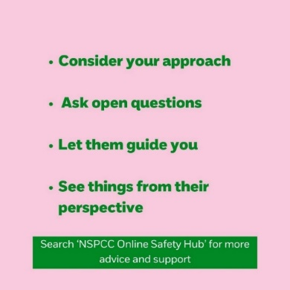  Online Wellbeing Post Two  Online Wellbeing: Start the Term with a Safe Digital Mindset  As the new school term begins, it’s the perfect time to talk to young people about how to stay safe and happy online.  🎥 In this uplifting video, children share the positive side of being online — from learning and creativity to staying connected with friends. It’s a great reminder that the internet can be a brilliant place when used safely and responsibly.  👉 Watch the video here:  💬 Top tip for parents: Start small. Ask your child what they enjoy doing online and build the conversation from there.  #OnlineWellbeing #NSPCC #DigitalSafety #BackToSchool #ParentingTips #OnlineSafety

